**IMPG Documentation**

**Initializing**

To start the program, use command prompt (not Python IDLE). Python’s IDLE does not register the required libraries to run this program. However, these are recognized in the PATH and can be seen/used by python when initialized in the command prompt.

The Image Magick Photo Generator currently resides in the IMPG photo on the desktop. Navigate there on the command prompt and open the file using py.

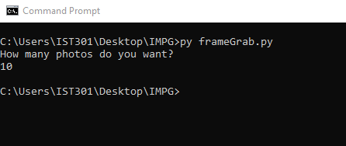

Photos will appear in IMPG\Converted. Go into the Converted folder to find the photos that you wish to view. Inputting -1 for user input activates devMode() which allows the user to directly access which option they wish to test.

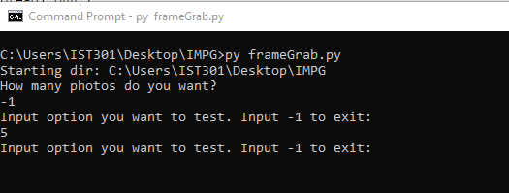

**Brief Overview (frameGrab.py)**

The camera is opened with cv2.VideoCapture. cv2.CAP_DSHOW is sent as a parameter to avoid creating an async callback error. cv2.destroyAllWindows() is run for the same reason. There are multiple methods created to use subprocess.call() to call the terminal to run Image Magick. Note that all subprocess.call() must end with **shell=True**.

All of these random choices are selected in the applyEffect() method. This method is called by the main() method until the specified number of photos have been generated. Photos can be written either as both their converted forms and original or can just have their converted forms saved. This option is controlled with:

keepOrig= **True**

Set this value to **False** if you wish to delete each new instance of a photo (highly suggested if running for large period of time. Note that if you intend to grab 100+ photos, the computer will automatically set keepOrig to **False.**

Note that photos are saved using a basic counter. Each photo is saved based on which number frame is was grabbed as, and all converted photos have a subtitle that describes which edit was performed on the photo. The counter will go up indefinitely. Once this number bypasses 100, it will begin deleting the older photos to preserve space on the system by introducing a delCount variable. This will increment with the count variable and will delete very old photos to make sure that only the newest 100 are presented to the user.

Adding options/commands to the program is easy enough. Research Image Magick documentation online or type convert in the command line to show all of its possible options.

The program by default waits 1 second ( cv2.waitKey(1000) ) after every call of applyEffect() in the main() method. This value can be changed by inputting a different number of milliseconds in the .waitKey() function. Commenting out this method/deleting it will make the computer grab photos as fast as it can convert them.

Finally, the program will show a video camera to the user to show which frames are being grabbed in real time, which are in turn being edited by the Image Magick. This option can be turned off by commenting out from the main() method:

cv2.imshow('IMPG Frame Grab', frame)